ChordWorld - User’s Guide

ChordWorld is an interactive musical chord keyboard. Once launched, the program display will look like this:

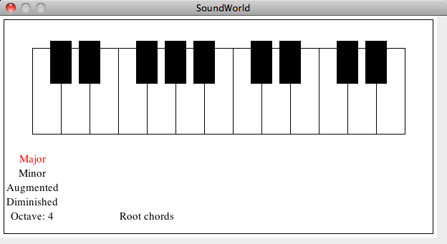

At the top is a musical keyboard. The leftmost key is always a C, and the octave is displayed at the bottom, set to 4 as default.

**Customizing ChordWorld:**

* This musical chord keyboard is highly customizable. The keyboard is designed to play 3-note chords, to teach musicians about all the different chord formations.
* There are four chord modes, which are. To change the chord mode, press z, x, c, or v to change the mode to major, minor, augmented, or diminished, respectively. The current chord mode is displayed in red.
* You can also change the octave. To increase the octave, type ‘+’ (shift and equals), and to decrease, type ‘–‘ (dash).
* Finally, you can change the chord inversion mode. The inversion mode is set to root chords by default. To change to first or second inversion, type ‘>’, and to go back to first or root, type ‘<’.

**Playing ChordWorld**

* To play a three-note chord, you simply press one button on the keyboard.
* The middle line of letters (A through K) represents the white keys, while the top row of letters (only W, E, T, Y, U) represents the black keys. The musical keys are laid out very comfortably on the computer keyboard.
* Practice with ChordWorld can lead to lots of musical exploration! ChordWorld will play the notes, make the corresponding keys glow red, and tell you the name of the chord. Learn how to play new chords, and learn how to use chord inversions to have more dynamic chord progressions in your music. Or just mess around and play a song! There are nearly 1300 different chords you can play with ChordWorld!